Dear Brownfield Action Instructor/Interested Party,

You are receiving this email because you have used the Brownfield Action (BA) simulation in the past or have expressed an interest in using the simulation. Since 1999 BA has been used by faculty and students at various universities, colleges, and high schools across the country as way to realistically simulate Phase 1, 2, and 3 environmental site assessments. Now, after 20 years in operation we are pleased to announce the release of the 4th iteration of this immersive platform. This new iteration is primarily a porting of the Flash code to HTML5. This was necessary because Flash is slowly becoming obsolete. Peter Bower, the original creator of BA, has spent the last 6 months collaborating with both Columbia University’s Center for Teaching and Learning as well as with Competentum, a third party software development company, to develop this new HTML5 version. This rewrite has also allowed other significant changes (described below) that consolidate resources and improve user experience.

The new simulation interface
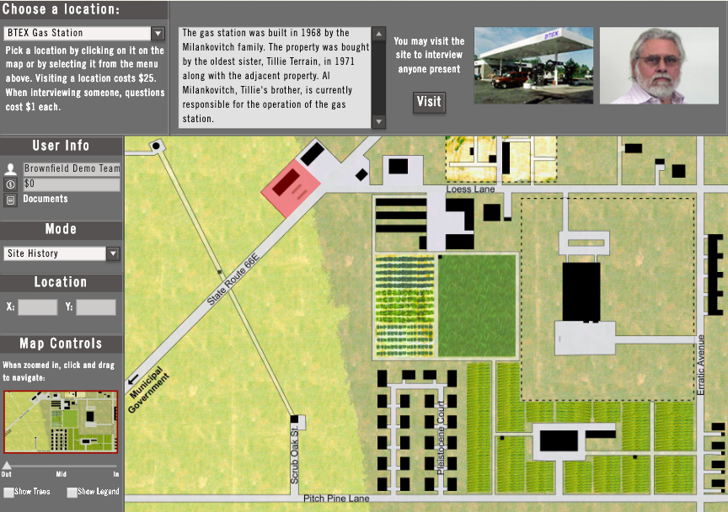

Changes to Brownfield Action Website(s)
- BA had resources on three different websites for registered users to use including the course & simulation page, a resources page, and a tools and certification quiz. These three original BA websites have now been consolidated into one site.
- The consolidation of the websites has allowed us to also consolidate the login process. Now there is only one portal that instructors need to log into in order to access the simulation and relevant resources.
- As mentioned before, a new simulation interface coded in HTML5 has been added to the site. The older Flash version has been removed.
- Finally, the site now has zip files for anyone that wants to quickly import online certification quizzes into a Canvas LMS course.
More details about the main changes for instructors as they navigate the new website are outlined below.

Front Page and Logging in
Go to <brownfieldaction.org> and you will notice that the main page has changed. Most of the original information is still here, but the key difference is that the new main page now has a login portal embedded. This is the only portal to log in now and gives you access to all the resources given to registered users.
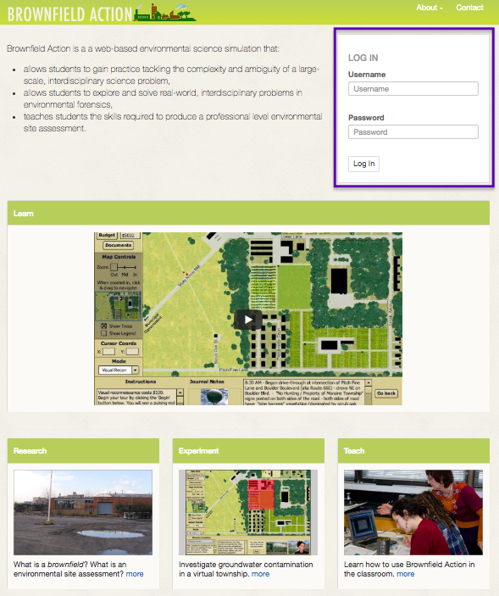

Conversion of Horizontal Menu Bar to About Menu
In the new website, the sub-menu links to relevant information have now been consolidated into an “About” tab.

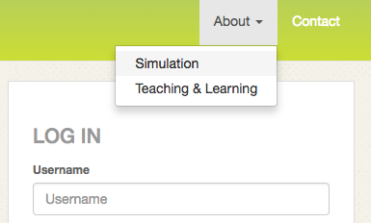

Registered Users
In the new website you can access the registered users resources after logging in on the front page. This page can be found either in the Resources tab [A] or in the “About” menu listed as “Instructor Resources.” [B]

Accessing the New HTML5 Simulation
The new simulation can be found under the Simulation tab.

This will lead you to the new HTML5 simulation interface.

BA Reference Material and Quizzes
You used to have to go to a different website to log in and find these resources. They are now in the Resources Section mentioned above. To access these resources click on Testing Tools Reference. The interactive quizzes have been removed and have been replaced with word documents as well as the Canvas Quiz Import zip files with instructions on how to import them. This is due to the increased usage of LMS at universities.

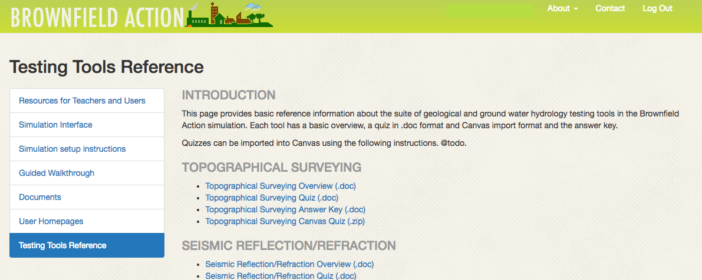

More
Brownfield Action (BA) is a web-based (www.brownfieldaction.org), interactive, three dimensional digital space and learning simulation in which students form geotechnical consulting companies and work collaboratively to explore and solve problems in environmental forensics and to engage in an organic, evolving, exploration of a simulated brownfield and local community. BA marries a civic-minded, constructivist approach to learning to the environmental, economic, and civic importance of brownfields and the toxification of the environment. BA was selected in 2003 as a “national model curriculum” by SENCER (Science Education for New Civic Engagements and Responsibilities), an NSF, STEM education initiative. What makes the BA SENCER model curriculum unique is that it includes a significant component of engagement with the civic dimensions of environmental contamination interwoven with the technical investigations being conducted by the students. This is fully described in Bower, et al., 2011. https://drive.google.com/file/d/1yN_vVb8vGxHMm7PxFDEs85feFq18Lgxf/view?usp=sharing
The BA simulation is also unique in that it has been disseminated to twelve colleges, universities, and high schools where it is currently being used in the classroom and a collaborative community of users has developed. BA is the only SENCER national model curriculum with a network of faculty collaborating in a community of practice. Moreover, this network has adapted the original simulation and its related products for use with a widening diversity of students, in a variety of classroom settings, and toward an expanding list of pedagogical goals. This is fully described in Bower et al., 2014. https://drive.google.com/file/d/1-wyV6TdcxOpVF0KbetWOnoT4hZ-k0Tg-/view?usp=sharing

